Table of contents

Section 1: Reception, Handling, and Preparation 2
1.1 Frames 2
1.2 Sensors 6
1.3 Hybrids 7
Section 2: Preparing for Assembly 11
2.1 System startup 11
2.2 Getting components ready 11
2.3 Database entry 13
2.4 Adhesive Preparation 14
Section 3: Running the Gantry Assembly Programs 17
3.1 TEC_MAIN and TOB_MAIN 17
3.2 Recovery Mode 23
Section 4: After Cure Survey 25
4.1 Surveying on the Gantry 25
4.2 Surveying on the OGP 25
4.3 Removing modules from assembly plate 26
Section 5: Module reinforcement 28
Appendix A: Troubleshooting Common Problems 31
Appendix B: Valve and digital I/O numbers 33

Section 1: Reception, Handling, and Preparation
This first section is designed to familiarize you with the process of steps and precautions necessary to go from receiving a box of module components all the way through to prepping those components for module assembly. The section is split up into three subsections corresponding to the three main types of module components: frames, sensors, and hybrids. Note that two major areas of module component preparation that are not covered in this discussion are hybrid wire bonding and hybrid testing.

1.1 Frames
There are seven types of frames that we use: TOB Single-Sided, TOB Double-Sided, TOB Stereo, TEC Ring 6, TEC Ring 5, TEC Ring 5 Stereo, and TEC Ring 7. The main distinction for our purposes here is whether the frames are TEC or TOB frames. TEC frames, in general, need less preparation.
Frames will usually be shipped to UCSB in padded cardboard boxes. Individually take each frame out of the box and put it into its own plastic bag for storage.
Frame handling rules:
- Always wear gloves
- Pick frames up by their edges if possible.
- Keep each frame in its own plastic bag.
- Do not flex the carbon fiber material, it will snap before it gives.
- Within their storage boxes, place frames on their side rather than face up or down.
A good visual inspection is necessary for all frames that are to be used in module assembly. We have created a series of steps to run through with all of the frames that identifies all the major problems that we have had with frames to date. The first step is somewhat obvious and must be done on both TEC and TOB frames:
- Check for any obvious damage to the kapton or to the carbon fiber frame.
If you are working with TEC frames skip to step 8. The TOB frames, on the other hand, have caused more problems over time and so require more attention prior to assembly. The following are for TOB frames only:
- Check that all the glue points have been properly glued (Refer to the Diagram 1). If one or more is missing you will have to go back and put a dot of glue under the kapton there (we use Araldite 2011 glue and an EFD pneumatic glue dispenser for this).
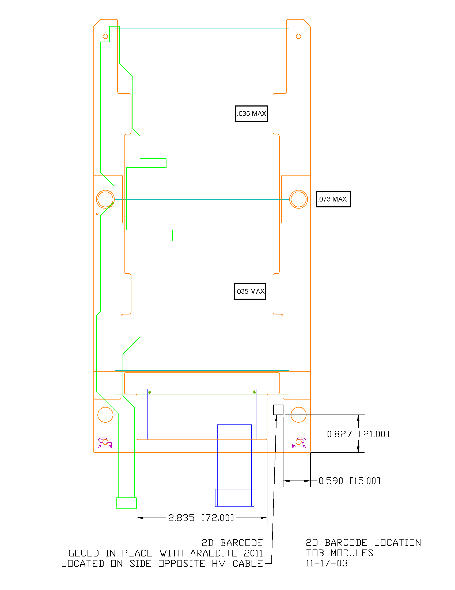
Glue point areas, Kapton to CF only
Diagram 1: 2D Barcode label and glue point locations on a TOB R/Phi frame.
- Put the frame on our special frame hole alignment-checking tool. This tools checks the alignment of all the frame holes that are necessary for the assembly process, it will be very obvious if a hole doesn’t fit properly.
- Check that the High-Voltage (HV) Wire does not interfere with the Pitch Adaptor (PA). We have developed a pretty good procedure for testing this issue. First, grab a 1-2-3 gauge block and position it up against the edge of the frame right around where the pitch adaptor meets the sensor. Next place the special horizontal PA locating tool on the side opposite of the HV wire. Now, bring out a dummy hybrid and place it flush up against this edge of the gauge block and the PA locating tool (see Diagram 2). If the HV wire touches the PA at all it will need to be moved.
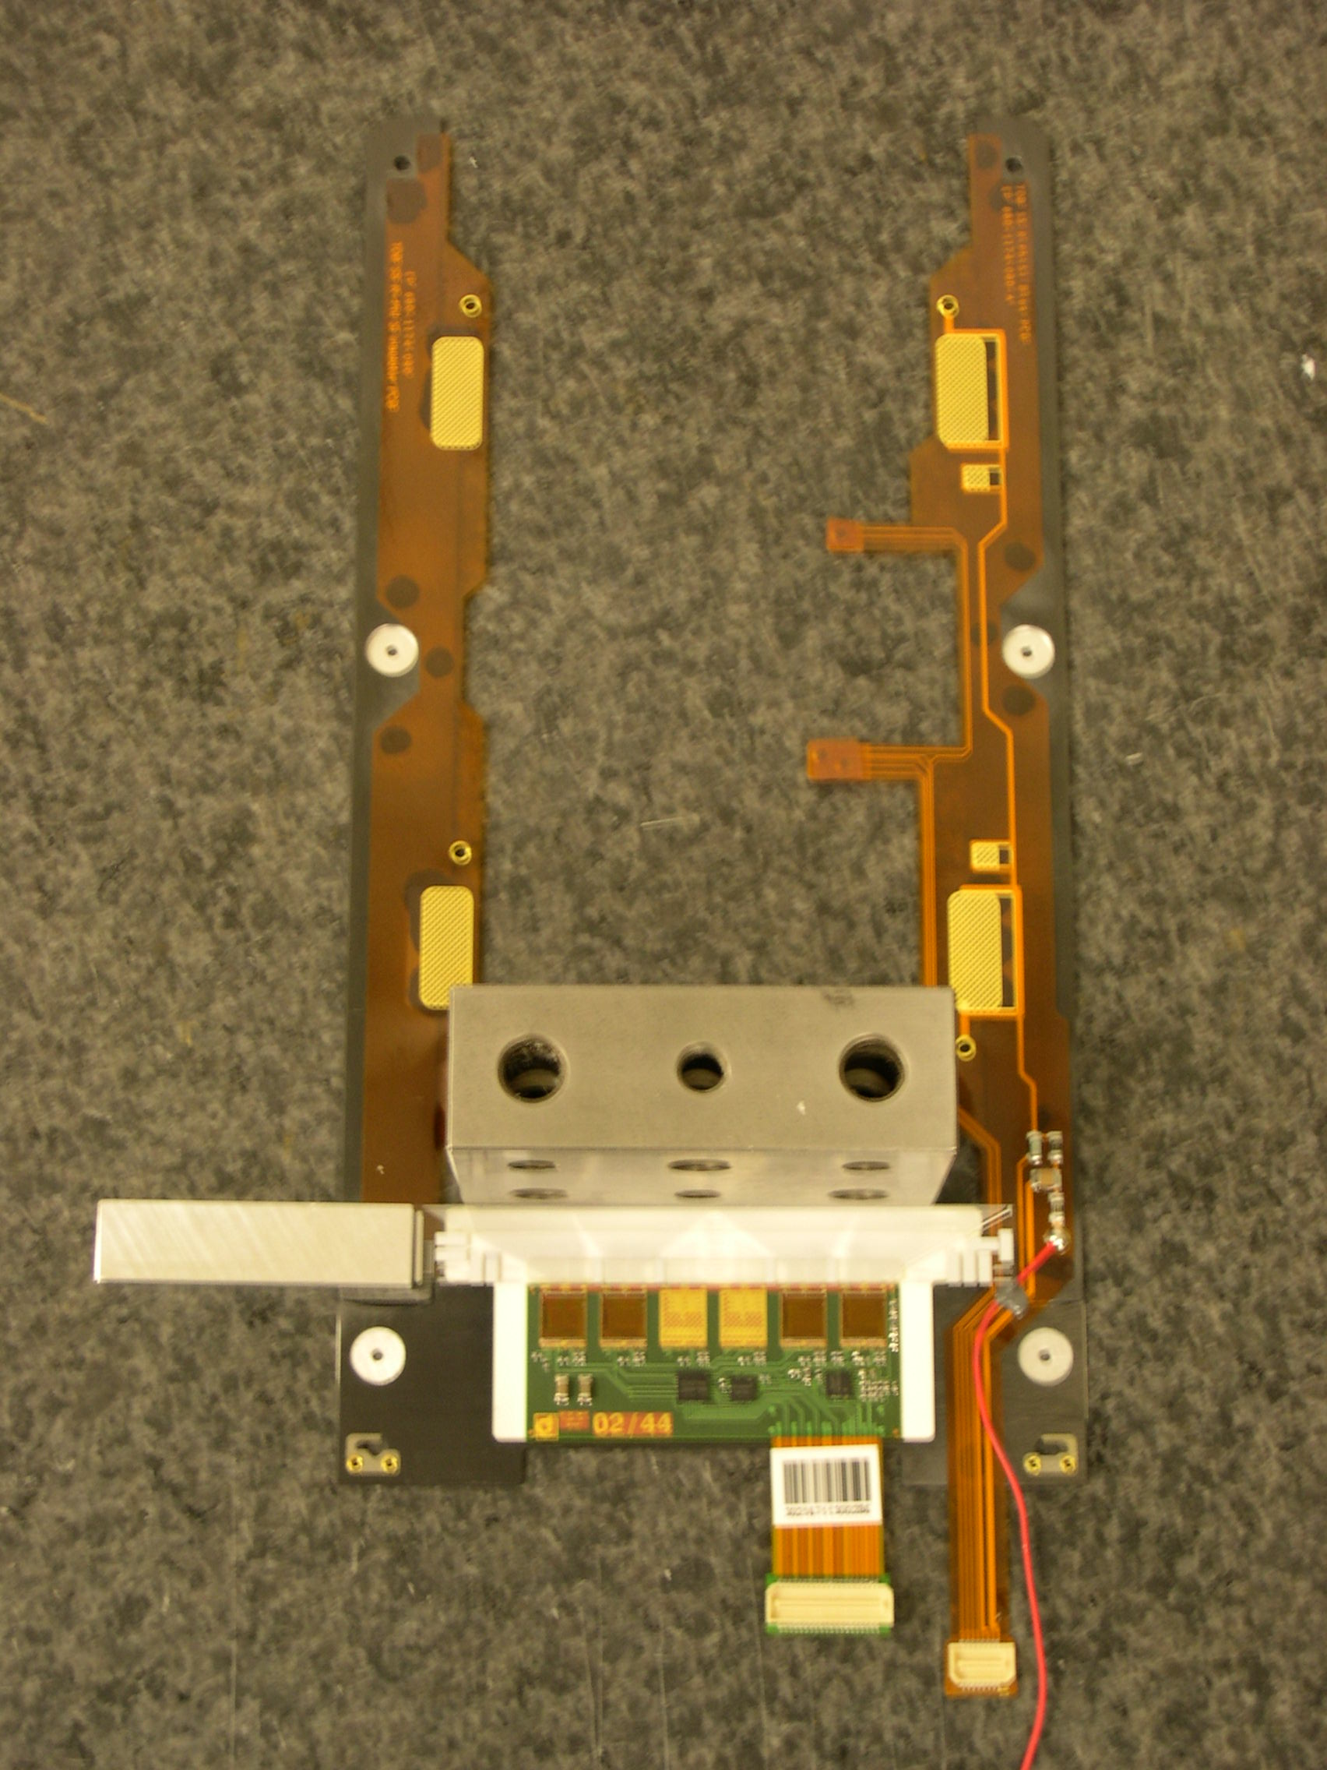
Diagram 2: Shows the setup for checking the position of the HV wire.
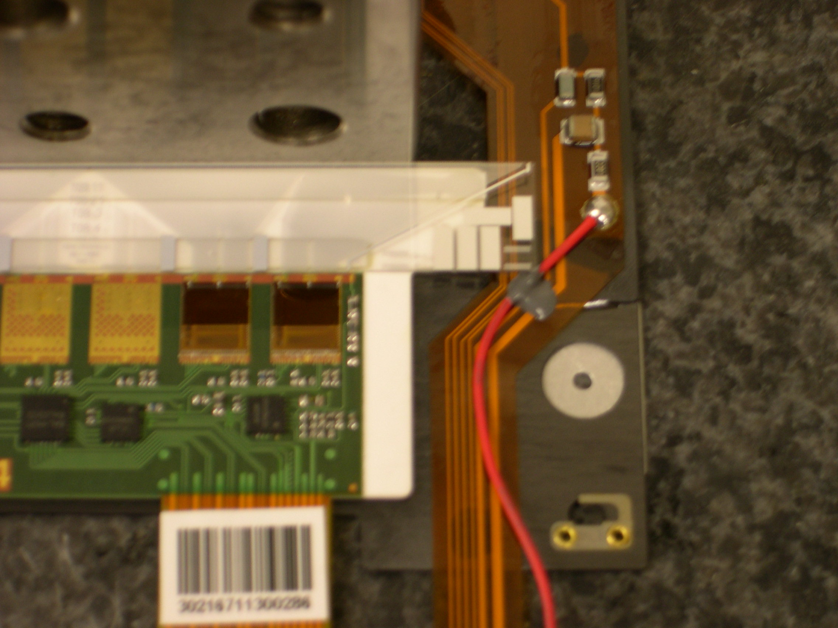
Diagram 3: Close up of the HV wire interfering with the PA.
To move the HV wire to a safer location, do the following:
  - Manually pull the HV wire out of the bead of Araldite 2013 glue. Hold the Kapton down firmly and grasp the wire close to the glue, pulling gently at first, increasing pressure slowly.
  - Use the heat gun to soften and remove any remaining glue on the Kapton. Do not turn the gun up very high or hold it to the glue for very long because it will burn the Kapton. We used a metal lab spoon to remove the excess glue. Remember that you do not need to remove all of the glue, just enough for the pitch adaptor to sit properly.
  - Trim away any glue left on the HV wire with a razor or your fingers. Again, you do not need to remove it all.
  - Reattach the wire using Araldite 2013 glue at the point highlighted in Diagram 4 and let it cure overnight.

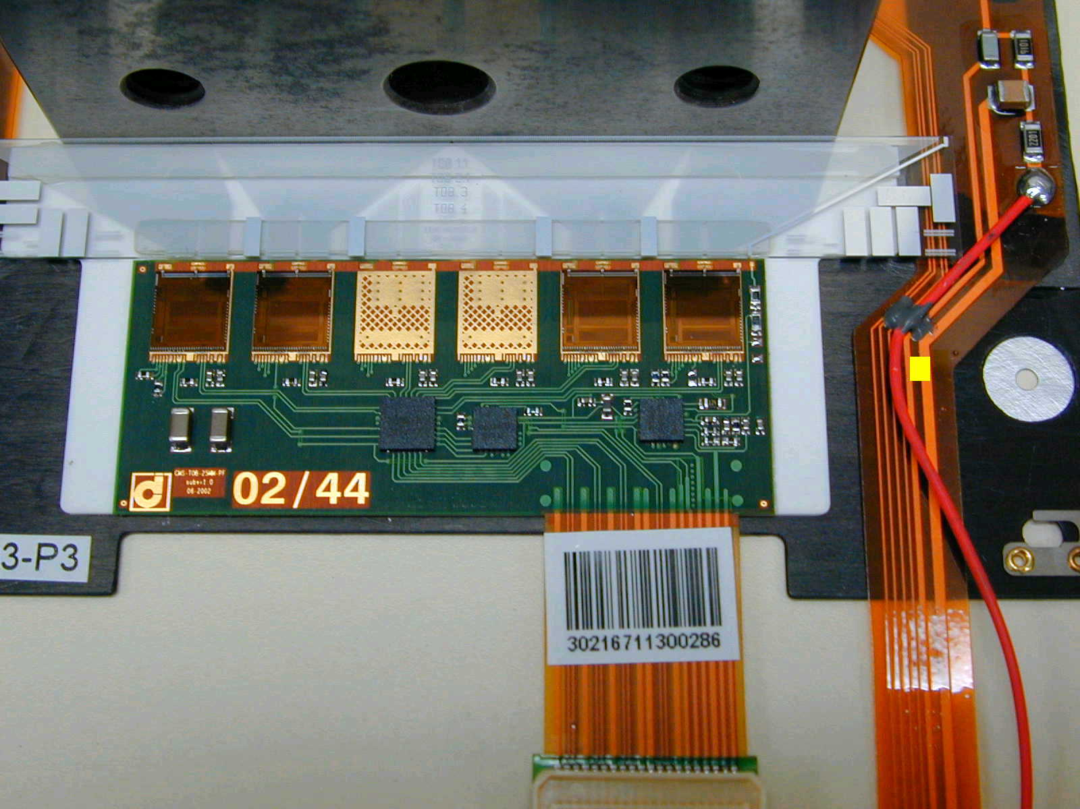
Diagram 4: Ideal location of the HV wire glue point.
- Remove all labels and clean areas that will be glued with alcohol. In addition to the glue point areas that might need to be glued, every TOB frame must be given a 2D barcode (again, see Diagram 1 for the location).
- Glue on the 2D barcode using Araldite 2011.
- Scan 2D barcodes to make 1D barcode labels; insert these labels into the plastic storage bags with the frame. Use the Wasp Barcode Labeler software loaded on one of the clean room machines and the attached Wasp Barcode printer to do this. There is a template located on the desktop for 1D barcodes.
- Add the number of good frames received and prepped into the UCSB Tracker Database. This is done via a webpage that is linked off of our main site http://hep.ucsb.edu/cms/cms.html. (Permissions will only allow you to do this on computers in the clean room)

1.2 Sensors
There are eight types of sensors that we use: OB1, OB2, W5A, W5B, W6A, W6B, W7A, and W7B. Fortunately for us, the handling and preparations for all the sensors is essentially the same. Handling sensors, however, is a much more sensitive job than frames.
Sensor handling rules:
- Always wear gloves, a mask, and grounding straps
- Whenever possible pick up wafers with the vacuum pick up tool
- Avoid scratching the top surface at all cost. When using the pick up tool do not allow it to move around on the sensor.
- If you have to pick up the sensor by hand, handle them carefully by their edges and avoid contact with the corners. Touching the corners may damage the fiducials.
- In general, keep the sensors in a sealed container except when inspecting or preparing them for assembly.
After a shipment of sensors arrives at UCSB, the first thing is to receive the transferred shipment in the database. Open the cardboard boxes and find the transfer barcode labels (these are usually large barcode stickers found on the outside of the sensor storage boxes). If there aren’t any transfer barcodes to be found, there will be a record of the transfer that can be found off of our group’s website http://hep.ucsb.edu/cms/cms.html. After finding the transfer information, log on to BigBrowser and follow these steps:
- Open BigBrowser by double clicking on the “shortcut to BigBrowser” icon located on the desktop of one of the clean room computers.
- One of the menus along the top of the window is called Connections. Scroll through its options and select DataBase.
- Choose the database type to be Production and enter the necessary password.
- Scroll down the WorkStations menu and select Transfer.
- Click on the “Get” button and enter or scan in the transfer ID when prompted.
- This should list all of the items in the transfer. Make sure that all the items listed here are accounted for in the boxes (a simple number check with probably suffice).
- Click on the “Update” button to officially accept the items. The program asks you if you would like to send a confirmation email, but this is a courtesy that generally is not done.
The sensors have now been received and the next step is to sort them into pairs of one near and one far sensor that will be used for module assembly.
-More here on sensor sorting-

1.3 Hybrids
There are 9 types of hybrids that we use here at UCSB, 5 types of TOB hybrids and 4 types of TEC hybrids. Receiving and preparing each different type of hybrid, just like with the sensors above, is essentially the same. This generalization does not hold with the wire bonding and testing of hybrids, but we are not dealing with those procedures here.
The first thing that must be done after receiving a shipment of hybrids, just like with the sensors above, is to officially receive the transfer in the database. So again, carefully unpack the cardboard boxes until you find the transfer barcode labels and follow the instructions outlined in the last section for receiving transfers.
Before moving on we should mention the guidelines to be followed when handling hybrids.
Hybrid handling rules:
- Make sure to wear a facemask, clean room booties, and grounding straps.
- Only handle hybrids on grounding mats (this combined with your straps keeps you grounded).
- Whenever holding or moving a hybrid touch only the tail of the hybrid whenever possible.
After the hybrid shipment has been transferred in the DB it is important to give each of them a good optical inspection. Follow these steps:
- Carefully remove tape from hybrids.
  - Hold hybrid in position either by placing one finger on the tail, or on the large numbers "02/44" on the bottom edge.
  - Pull tape off, away from any local edges of the hybrid or pitch adapter.
- Leaving the hybrid in its container, but with the tape removed, place it in the focal plane of a Stereoscope.
- Visually inspect all the wire bonds on the 4 APV fronts:
  - Inspect the top and bottom wire bond pads, each row contains two wire bonds and four feet
  - Inspect the wire bond elbows
Note that the inspection goes faster if the stereoscope if fixed in focus and the box is moved to bring adjacent wire bonds into focus. The magnification is set so that one wire bond just fits in the viewable region. In this way, all the wire bonds can be inspected in 3 passes whereby the box is slid laterally under the scope; one for the lower pads, one for the elbows, and one for the upper pads. One very careful pass at a lower magnification could also be sufficient.
- Visually inspect all the wire bonds to the pitch adapter.
After the hybrid has passed this initial inspection, it needs to be put on a carrier plate that is used for ease when the hybrid is later bonded and tested. In order to do this, run through these next few steps:
- Grasp the hybrid where the tail meets the hybrid and remove it from the box to the work surface.
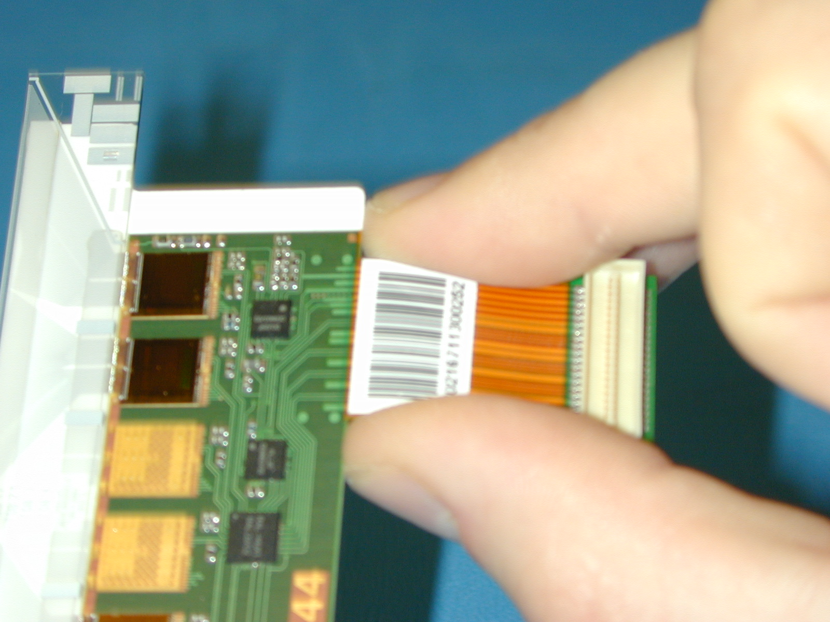
- After making sure the clamps are in place and threaded, gently drag the hybrid onto the mounting plate by its tail and slide into position.
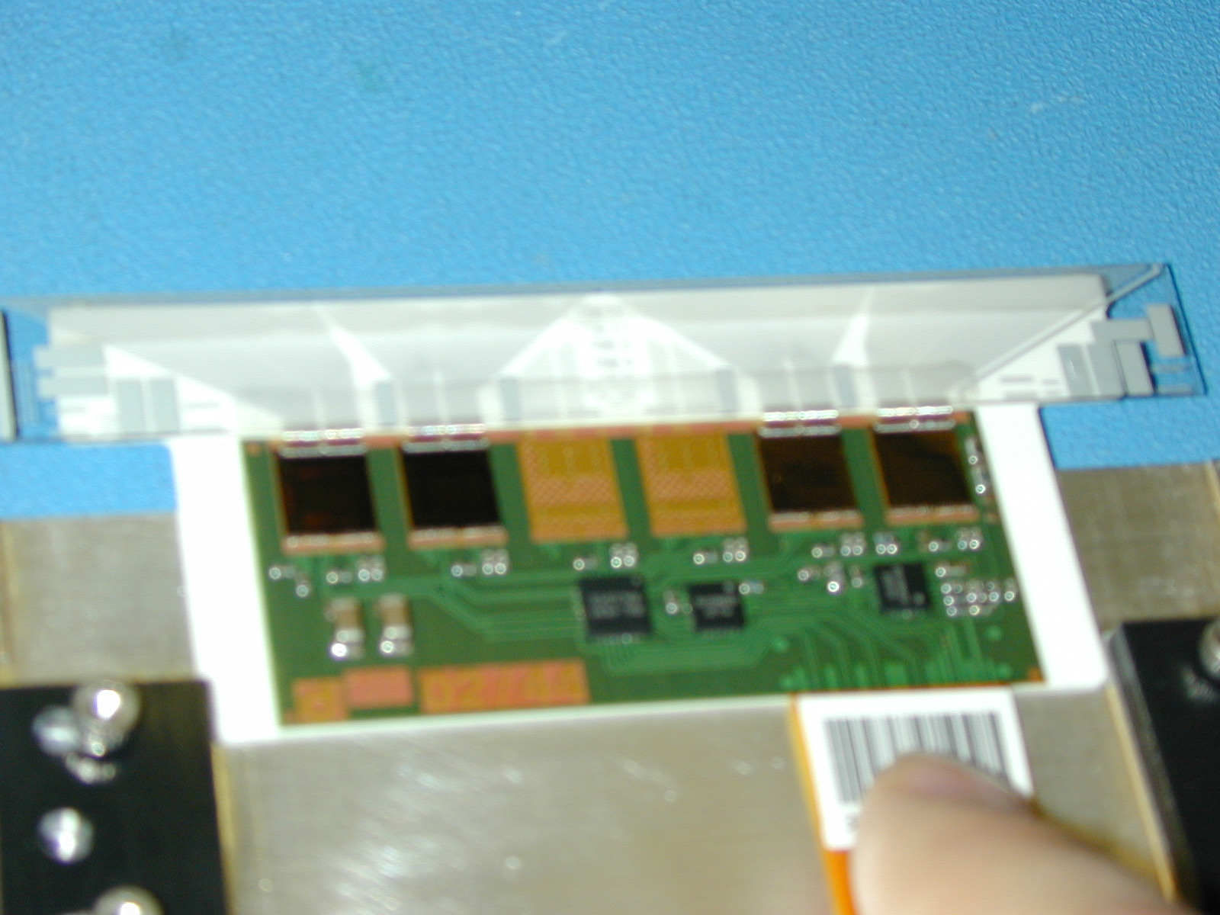
- Using a ball driver, push the outside edges of the clamps so they slide into position over the hybrid edges
- With this driver fasten the clamps just until they are snug. Do not over tighten!
- Very carefully secure the top tail strap. Extra caution should be used because of the close proximity to the hybrid. Grasp the shaft of a standard allen driver between thumb and fore finger and secure the screw using the index finger. Thread the first screw very carefully and then the second, waiting to tighten both. Now tighten both using a ball driver. (In the picture below you will not be attaching a cable to the hybrid tail, so don’t worry about the tail.)
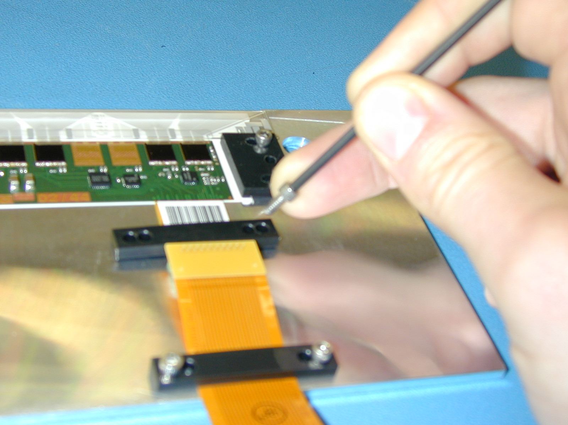
- And finally, transfer the hybrid and plate to a labeled box and store it.
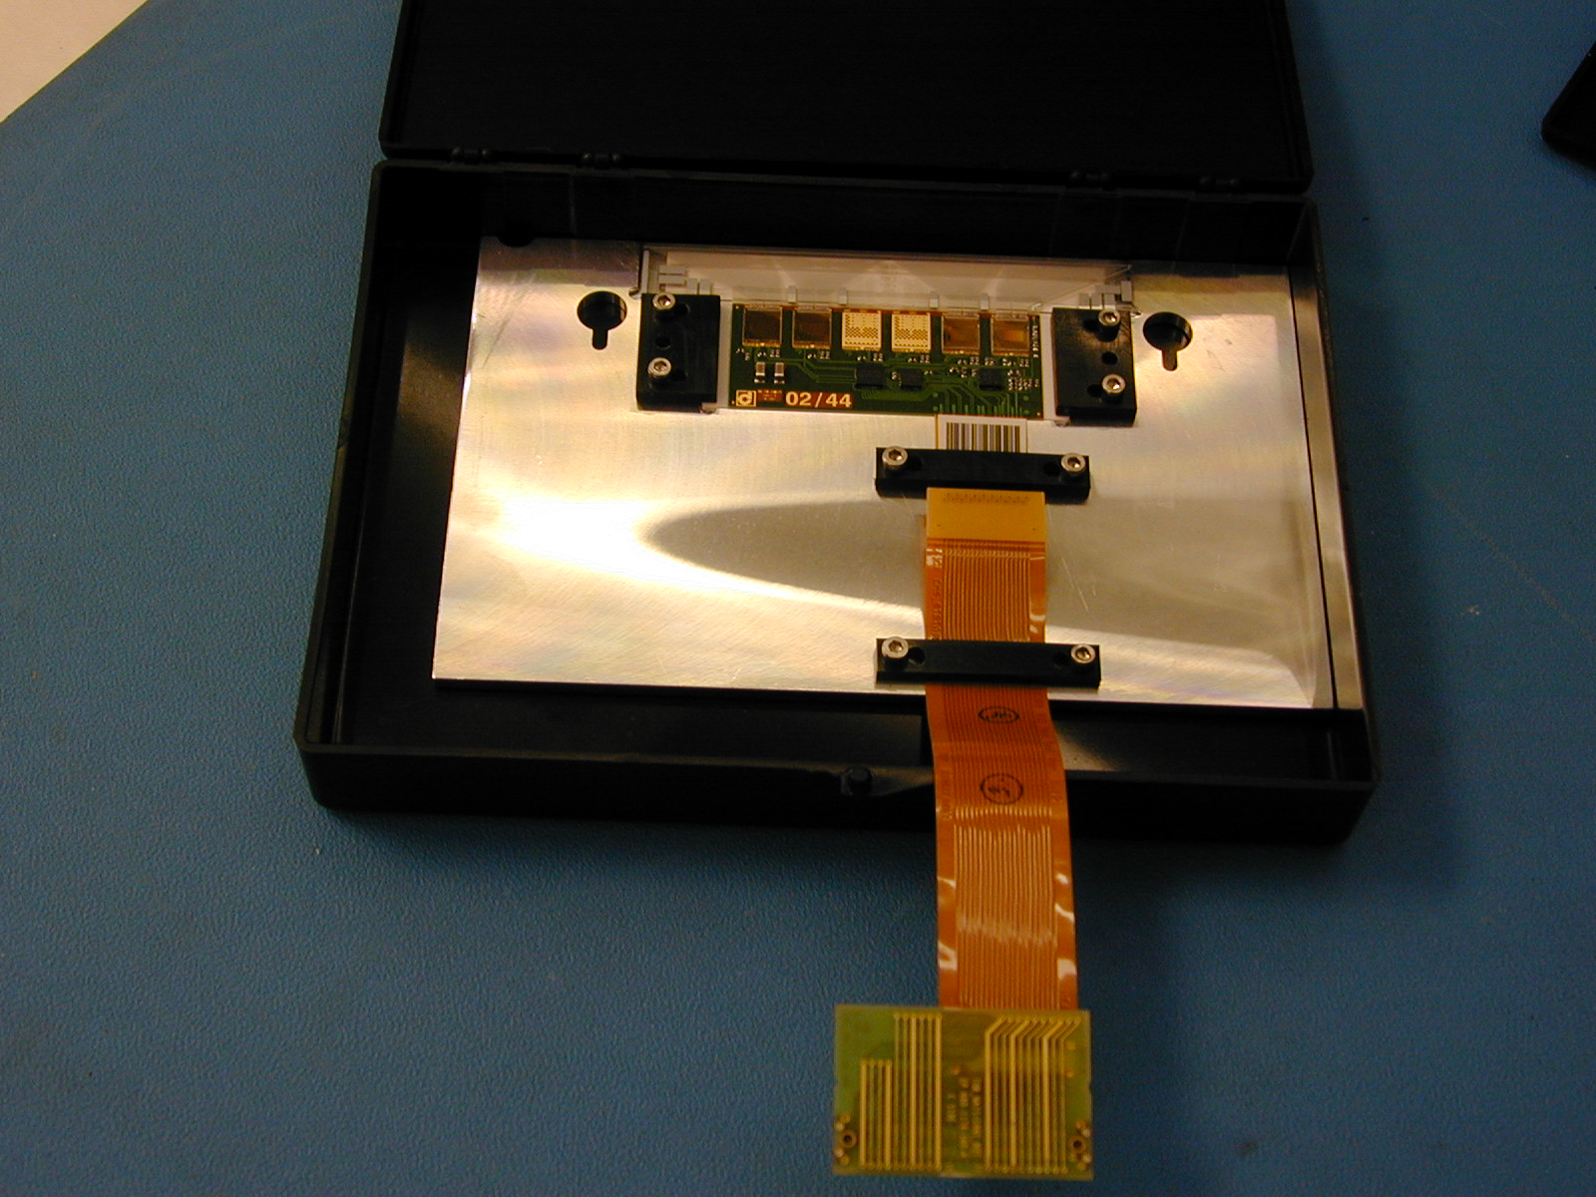

Section 2: Preparing for Assembly

2.1 System startup
Make sure all components of operation are turned on:
- The gantry vacuum (UPS located next to OGP).
- The curing vacuum (UPS for large curing pump is located next to the OGP, the UPS for the small curing pump is located in the test room just inside the door).
- The DR500 and I/O box (Connected to a single UPS located on gantry rack next to PC).
- All components of the PR system; light, line generator, and monitor.

2.2 Getting components ready
You will need 3 frames, 6 wafers and 3 hybrids for every plate. Make sure you know what kind of modules you will be building, whether they are TOB or TEC and which variety so you can get the proper components. Chart ? in appendix ? has information on what sensors and hybrids go with each types of module.
- Pick the assembly plate that you will be using making sure it is the right type for the modules you will be building. Make sure the plate is clean, wiping it with alcohol as needed. Also make sure there is a clean piece of electrical tape to do the glue test on. Once the assembly plate is clean you are ready for frames. Place the frames onto the assembly plate, making sure that they are pushed all the way down on the pins and for TOB frames make sure that the clips are not deformed.
- If you are making TOB modules make sure to put the 1D barcode that goes with each frame on the clip for that module so you can easily keep track of module names. Also for TOB frames you should check the conductivity of the high voltage wire. To do this use a DVM and clip one lead on the end of the red HV wire touch the other lead to a sensor pad, there should be a resistance of around 11.3 KOhms. Check both sensor pads and both bias pads.
- If you are making TEC modules check that the ceramic stiffener is not cracked or broken and that both ears are glued down. Also place the stiffener that will be glued between the sensors, it goes in the groove on the Teflon sensor pad. Make sure that it is seated properly in the groove.
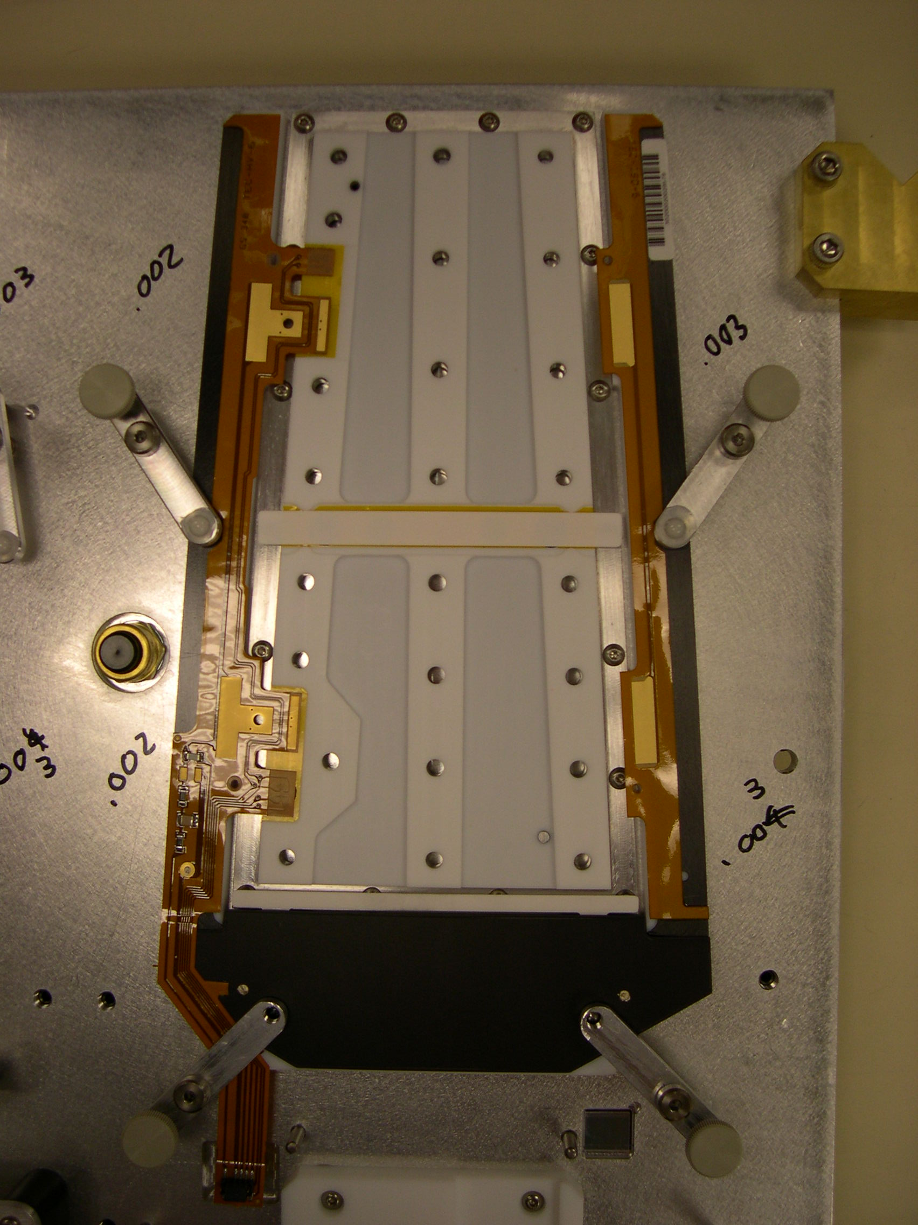
TEC frame mounted on assembly plate with ceramic stiffener.
After the frames are properly placed on the assembly plate, give them a quick cleaning with some alcohol.
- Get wafers from cabinet. They should already be sorted so that they are in their boxes in pairs, the near sensor in front of the far sensor.
- Place the sensors using the vacuum wafer pickup tool. Make sure that side of the sensor with the double line is facing up; this should not be an issue with TEC sensors as they will only fit on the supply plate one way.
- When placing the sensors making sure you are placing them in their intended positions. Place one at a time and after the sensor is placed, write on the cover what position and where that sensor was placed, i.e. position 1, near. This is very important to keep track of this so the info is properly entered into the database.
- Get hybrids from cabinets. Check to make sure that they are the correct type and that they have all of their wire bonds. Label what position you would like each to go in so you can keep track for database entry.

2.3 Database entry
Now that you have all the components you need to register them in Big Browser.
- Open Big Browser and select the production database.
- Once in the production database go to “WorkStations” and select “Registration”.
  - Select object as MOD, select type (ref material), location should be set at Santa Barbara, change it if its not. Type 1 modules are ones that use HPK sensors, type 2 use ST sensors. If you are building a modules out of bad parts be sure to mark the module as faulty when you are registering it. Scan the module barcode, and press enter. You can scan another barcode for another module at this point. When all the modules you wish to register have been entered, click on the update button.
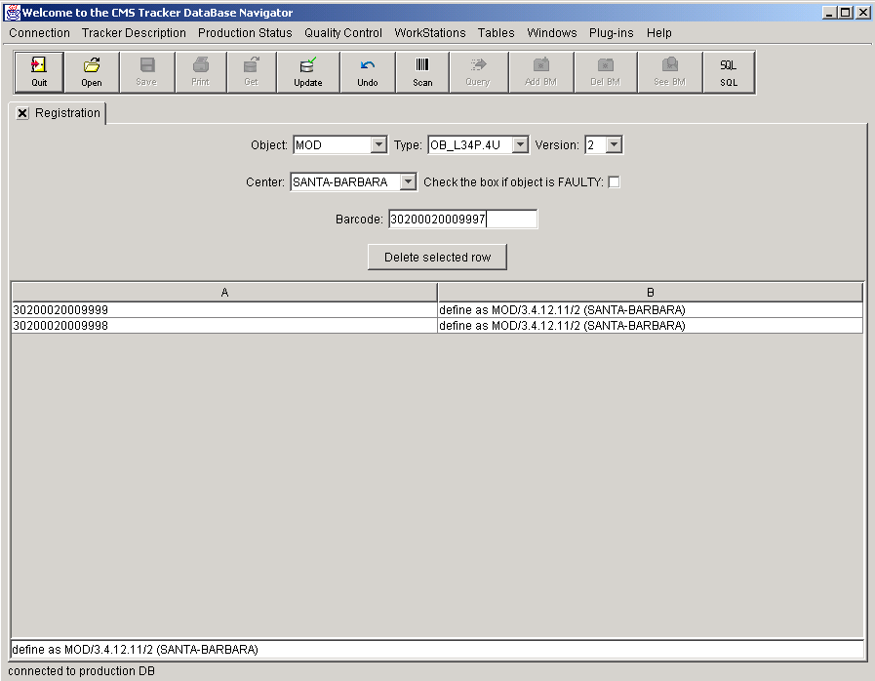
After the modules have been registered they need to be “virtually assembled”.
3. In the production database go to WorkStations and select Assembly. Once in Assembly click Add Card. For your new card you must add the module components, to do this click Add/Remove Component three times. Scan the module or “parent” barcode. In the subjects list, scan the hybrid barcode, the near sensor barcode and the far sensor barcode. The position for the hybrid is 1, the near sensor is 2, and the far sensor is 3. Once all the components have been added click the update button. Do this for each module you will be assembling.
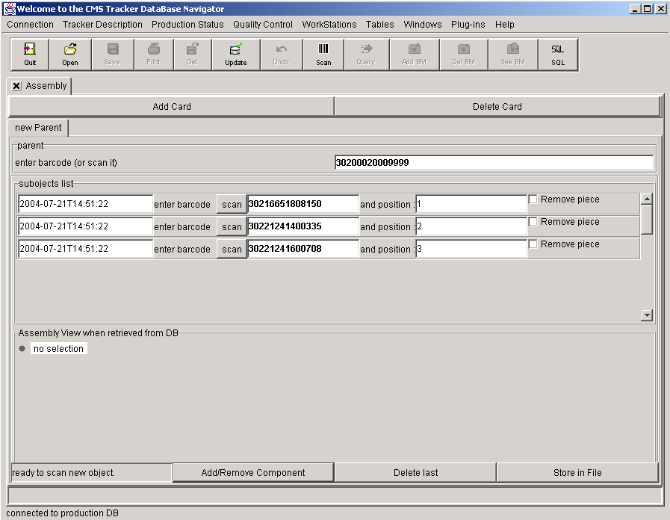
With everything entered into the database you can place the assembly plate onto the gantry. When you do make sure it is pushed back all the way against the locating pins. Put the hybrids in the respective positions pushing against their three locating pins. Place the hybrid pick up tool on the hybrid making sure the suction cups are where they should be. For TOB they should be on the ceramic plate, for TEC ring 6 they should be on the hybrid not touching any of the components or the wire bonds, for ring 5 and ring 5 stereo one cup will be on the hybrid and the other will be on the pitch adapter. All the suction cups should be glued down by they are still able to move a little so care should be taken while placing the hybrid tools. Now is also the time to connect the curing vacuum hose. Remove one of the curing vacuum hoses from the curing cabinet and attach it to the curing vacuum value on the assembly plate tightening it until it is just hand tight. Now you are ready to prepare the adhesives.

2.4 Adhesive Preparation
RTV 12
- Measure 10 grams of base on the scale. The easiest way to do this is to first pour a small amount of base into an aluminum cup, then pour from this cup into another aluminum cup on the zeroed scale.
- Add micro bubbles. Re-zero the scale and wearing a mask use a mixer to get a small amount of micro bubbles, slowly add these to the base until you have added 0.1 grams.
- Add hardener. Re-zero the scale and use a dropper to add 0.5 grams of hardener to the mixture. Mix well, the mixture should be milky white and uniform in appearance.
- Evacuate the air bubbles. Close the purge valve and then slowly open the vacuum valve. The mixture should bubble up quickly at first then more slowly. Let the glue sit in the evacuation chamber for a few minutes until air bubbles cease.
- Fill syringe. Close the vacuum valve and slowly open the purge valve. Pour the glue into a 5cc syringe fitted with a purple tip. Do not fill the syringe more than ?? cm. Add the piston and push the piston down until it just touches the top of the glue.
- Put the syringe onto the dispensing tool. Make sure to push the syringe up as far as it will go and turn it right to lock it into place.
- Check the tip length with the tool. Place the glue on the tool rack in position 2. Be sure that the tool is sitting properly on the 3 pins on the racks. [ref the glue mixing procs perhaps in an appendix]
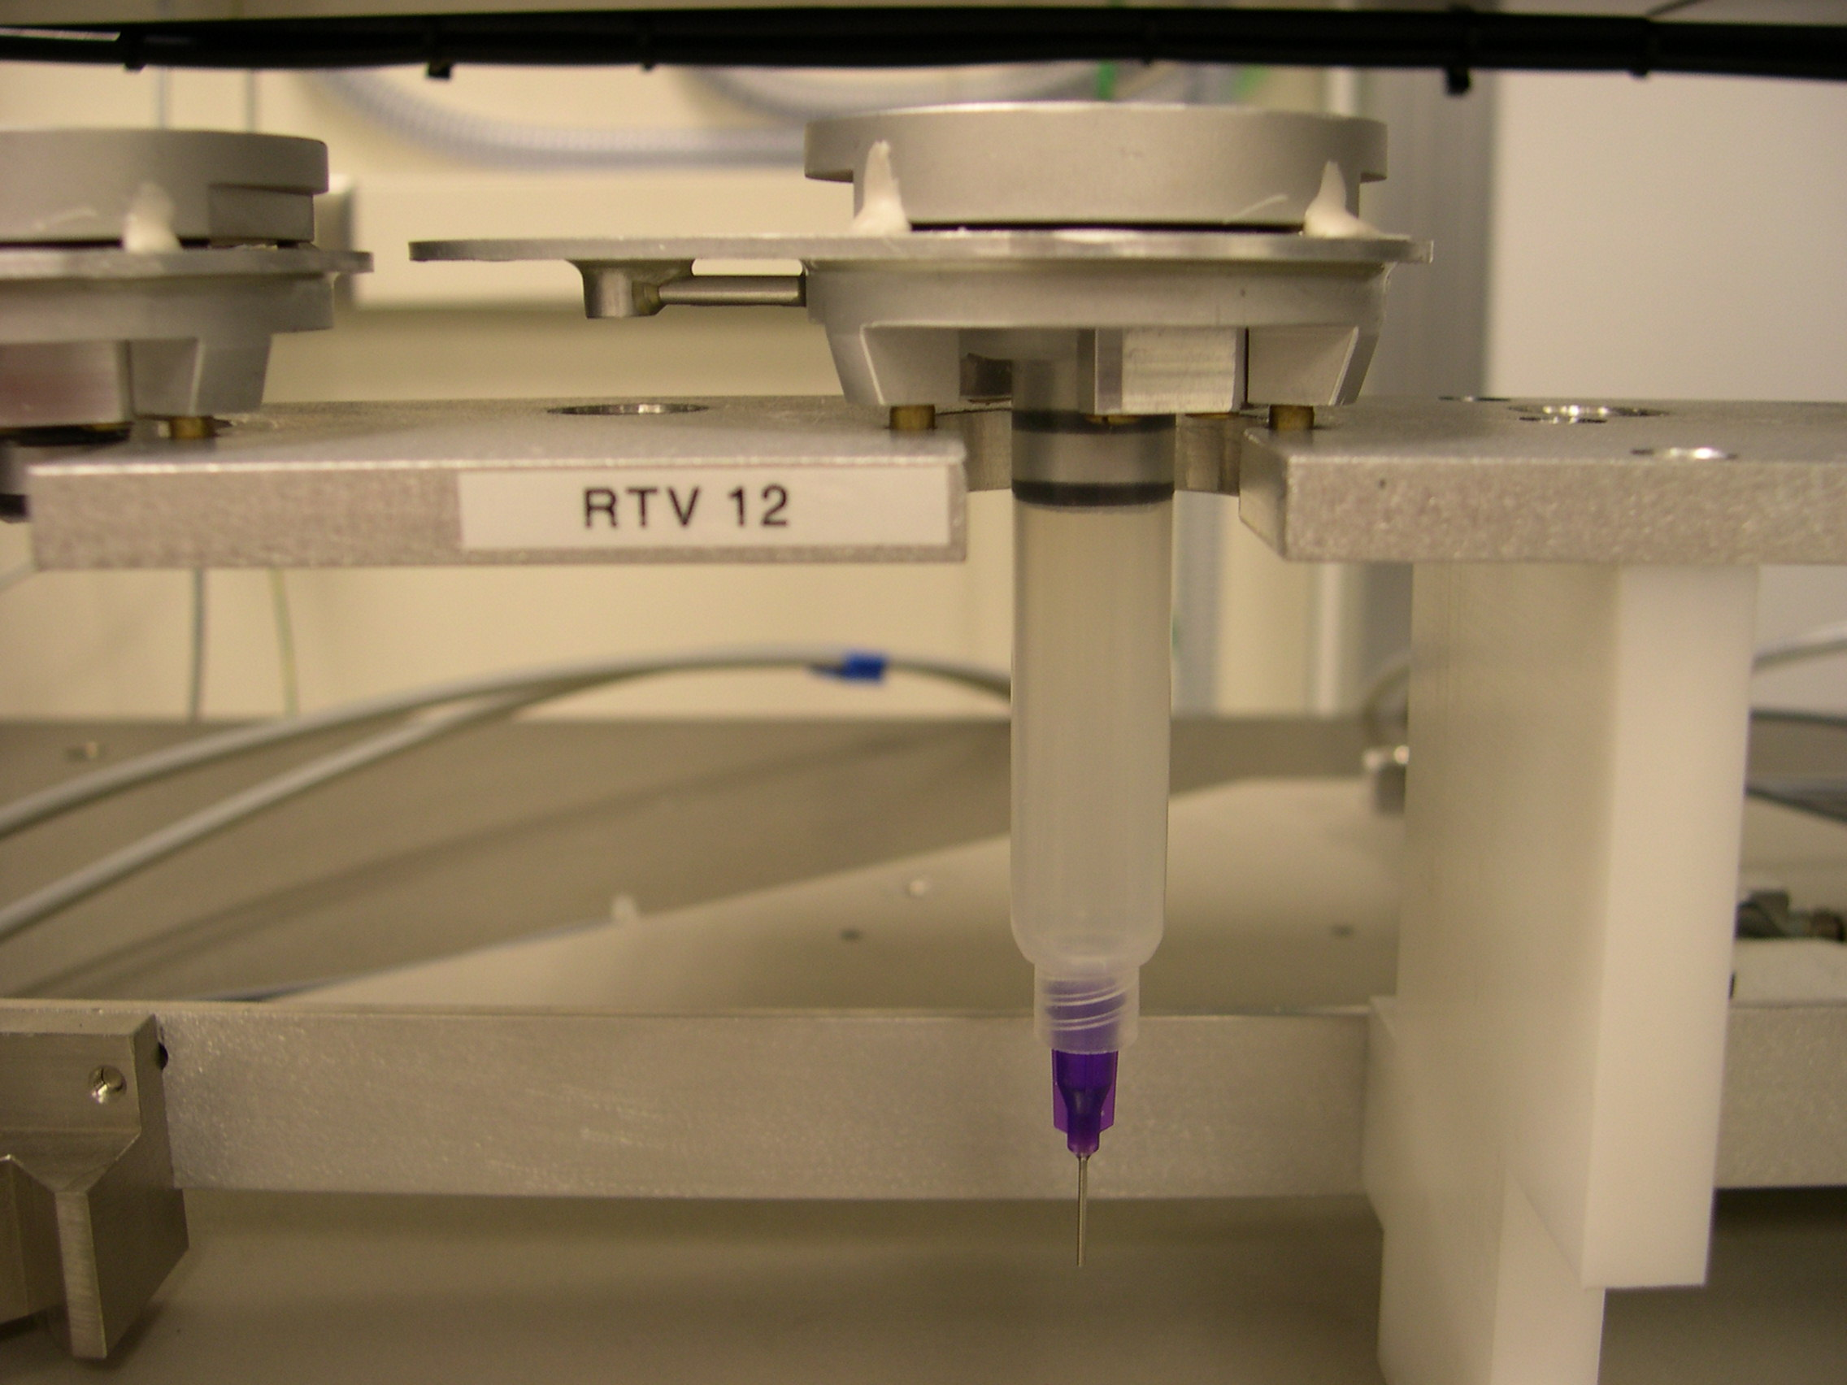
Syringe tool seated properly on the tool rack.
Dow Corning 3140
- Fill syringe. Add the Dow Corning 3140 to a 5cc syringe fitted with a green tip. Fill the syringe about ?? cm. Add the piston and push down until it just touches the glue.
- Put the syringe on the dispensing tool. Push it as far as it will do on and turn it right to lock it into place.
- Check the tip length with the tip-checking tool. Place the syringe on the tool rack in position 1, making sure it rests properly on the 3 pins, see picture above.
Silver epoxy
Use a new package of silver epoxy for each plate of modules.
- Remove epoxy from package and take of clip keeping the two component separate..
- Mix. Use the mixing tool to mix the epoxy, about 100 strokes.
- Dispense epoxy onto glass slide. Use a razor to cut one small opening in the package and put a small amount of epoxy onto a glass slide. It does not take much epoxy so you do not need to worry about getting most of the epoxy out.
- Add to bias pad. Using the curved scraping tool put a small amount of epoxy on the bias pads of the frames. On TEC frames you should use two small dots for each pad, only one is needed for each pad in TOB.
You do not need to put a lot of glue but you should make sure there is enough so that it makes good contact with the back plane of the sensor. If the dots look like small Hershey’s kisses you probably have about the right about of silver epoxy. With all the components on the gantry and the glues all mixed you are now ready to start assembly.

Section 3: Running the Gantry Assembly Programs

3.1 TEC_MAIN and TOB_MAIN
- Open and begin the pattern recognition software via the “Shortcut to patrec_prod” icon on the gantry computer desktop.
  - Select “pat rec for gantry main.vi” as the file to opened when prompted
  - Hit the arrow in the upper left corner to begin the program
  - Set the program to run remotely by selecting the box under “remote”
- Open the MMI Unidex600MMI icon
- Load the correct assembly program to run (either TEC_MAIN or TOB_MAIN)
  - Click on <File Menu> located on the bottom of the screen or press F4
  - The name of the program is located at the bottom of the screen. If you want the another program you must select <open> or press F8
  - Select the correct program from the menu and click ok
  - Click on <Run Menu> or press F5
  - The buttons of the right hand side of the screen will change to the Run Menu, click on Compile or F7, when the program finished compiling (messages are posted in the bottom window) click on Download or F8, when it is finished downloading, click Run or F9.
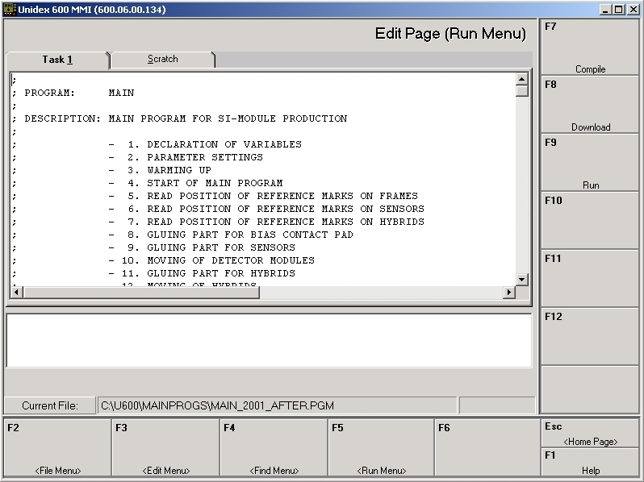
- Click Cycle Start or press F2 to start running the program.
Before doing this, you should go down the abbreviated checklist on the gantry console to make sure you have everything ready to start production. If at anytime during the running of the program you want to pause the program click on Feedhold or press F3, this will pause the program without interrupting anything. Click release or F3 to continue running the program. Likewise, if absolutely necessary you can click Abort or press F4 to abort from the program. This option is usually used as a last resort.
Once the main program is running a number of prompts will pop up on the screen. Below we have included descriptions of the prompts and their answers.
- Reset valves? Y/N?
Generally yes, however if you are in recovery mode and/or there are already components on the assembly plate answer no here, otherwise the vacuum holding the components down will be released.
- Start Module Production? Please put the platform on the gantry including components
Yes to start production.
No will end production.
- Select the Sensor Manufacturer
Options:
ST
HPK
- Select Assembly Procedure
Standard - this is the option usually used. With this option you will not be asked whether or not to perform each action; module production will proceed with little operator intervention.
Step by Step - use this option when you want to skip certain steps in production. This is often the case when performing dry runs. Regular module assembly can be performed with this option, but requires more operator intervention.
Recovery - use this option when a previous run was aborted. This will allow you to start the assembly in the middle of the program, skipping steps already performed. Recovery mode is discussed in more detail at the end of this section.
- Select module type
If you are running TOB_MAIN you will be given the following options:
SS R-PHI (RHS)- Single-Sided R-Phi frames, the thermister pads are on the right hand side.
DS R-PHI (LHS)- Double-Sided R-Phi frames, the thermister pads are on the left hand side of the frame.
DS-STEREO - TOB stereo frames.
If you are, however, running TEC_MAIN you will be given these options:
TEC Ring 6
TEC Ring 5 R-Phi
TEC Ring 5 Stereo
- Index of assembly platform
The number of the assembly plate, this is clearly labeled on all the assembly plates below the center hybrid pick up tool.
- Number of modules
Integer value 1-3, the number of modules you are going to assemble. Be sure that siliindex.dat is set to the same number you enter here (really only an issue if you are building less than 3 or have recently). Siliindex.dat is located in the workspace folder, note that this is only an issue if you are building less than 3 modules not starting in position 1 (for example, if you are building only in positions 2 and 3).
- Use database? Y/N?
Answer yes to this question to use the database to access the information previously registered and to output reports to the database after assembly is completed.
- Insert barcode
Scan the barcode for the module in position 1 and click ok, or press enter. Repeat for modules in positions 2 and 3.
- Insert name
Just enter the operator’s name.
- Temperature
The default is 23°C, change as necessary. There is a temperature and humidity gauge on top of the curing cabinet.
- Humidity
60% RH is the default, make any necessary changes.
At this point if you are in Standard Production Mode you will not get any more prompts until the glue tests are performed. Regardless, you should still pay close attention because you can almost be guaranteed that something will go wrong when you are not.
If you are in step be step mode you will receive the following additional prompts:
- Switch on valves for module construction? Y/N?
Answer yes to this to switch on the valves, this sucks down all the assembly components, including sucking down the plate and engaging the plate clamps. If you are assembling TEC modules, this is a good time to verify that all of the stiffeners have been sucked down properly. Make sure that the stiffeners have not caught an edge and are lying flat in their groove.
- Use pattern recognition? Y/N?
Answer yes to this question. You will need to use the pattern recognition to measure the fiducials on the assembly plate and the assembly components. If you select no, or choose not to use pattern recognition, you can still measure the fiducials by hand, but you will not measure them as accurately as the software would have.
- Measure assembly plate position? Y/N?
Selecting yes uses the pattern recognition to measure the fiducials on the assembly plate. To measure the fiducial position, first use the joystick to focus. Once the fiducial is in focus, press the button on top of the joystick. Next, use the joystick to align the cross hairs on the screen in the center of the fiducial. It is not imperative that it is perfect, that’s what the pattern recognition is for. Repeat these steps for the other assembly plate fiducial, and for all other fiducials measured with pattern recognition.
Otherwise, choosing no uses nominal values for the plate position. This decreases module assembly precision because plate positions vary from run to run.
- Read position of reference marks on sensors? Y/N?
Select yes to read the fiducials on the sensors. This is necessary to get an accurate measurement of the positions of the sensors so they can be placed as precisely as possible. Follow the same procedures as above to measure the fiducials. Again, choosing no decreases module assembly precision because component positions vary from run to run, but in this case you can also choose to use values from a file.
We should also mention that occasionally after measuring both fiducials of a sensor or hybrid that the gantry will respond that the distance between the two fiducials is either too large or too small. When asked what to do, re-measure them looking at the outputted photo from the pattern recognition software. If it looks like the pattern recognition is doing a good job and you still get the error, just continue on. We have not had any problems with skipping this problem in this manner.
- Read position of reference marks of hybrids? Y/N?
Yes to read the fiducials on the hybrids, for the same reasons as above.
- Bias glue? Y/N?
Answer no to this question. We now put the bias glue on the frames by hand prior to running. See the previous section for these gluing procedures.
- Si glue? Y/N?
Yes to dispense the DC3140 glue used to secure the sensors. The gantry will first dispense a test strip of glue, if the test strip looks good answer yes when prompted. If the test strip does not look good, select no and the gantry will dispense a second test strip. If there is still a problem, you should figure out the cause. If needed, you can set down the syringe when you are asked to respond to a bad test. This is a helpful option because you can correct a problem with the syringe without interfering with the assembly program.
Also take notice of any thermisters that are tilted up. Each thermister will receive either one or two dabs of glue, and if they are too high the syringe will miss them when it is lowering to dispense. The quick solution to this issue is to hold down any that are high while the syringe is lowering and dispensing. The longer solution to this is to manually clean the glue off of the Teflon after the glue misses the thermister and to manually dispense a dab of glue from the extra mixed onto the thermister.
- Move sensors? Y/N?
Yes to move the sensors. While the sensors are being moved watch the vacuum pressure gauge on the gantry console. If something is obstructing the sensor from making a good vacuum you will see it here with a sudden decrease in pressure.
No will skip moving the sensors and go to the next step.
- Hybrid glue? Y/N?
Yes to dispense the RTV12 glue for the hybrids. There will again be a glue test.
No will skip to the next step.
- Move hybrids? Y/N?
Yes to move the hybrids. This is the step that historically has had the most problems. Make sure to watch carefully and be prepared to pause the program if something looks like it might be out of place.
No will skip to the next step.
- Check marker positions? Y/N?
Answer yes to check the modules fiducials. You will be given 3 options if you answer yes:
Hybrids and sensors (This is the default)
Sensors only
Hybrids only
If you assembled modules with both sensors and hybrids then you will most likely want to measure all the fiducials. There shouldn’t be any reason to measure only the sensors or only the hybrids unless you are doing dry runs with only one or the other.
No will skip to the next step.
Both Step-By-Step and Standard assembly modes give the following prompts:
- Move assembly plate for glue curing? Y/N?
Yes to cure the assembled modules in the cabinet. Note that you should have the curing vacuum hose already attached. This should have been done prior to the start of assembly. If it wasn’t, carefully connect it now.
Select No to leave the plate on the gantry while curing.
If you selected yes to last question, it will ask you to connect the external vacuum source (the curing vacuum hose) and then click ok to reset the valves. Make sure you turn on the curing vacuum valve for that hose, it is located next to the curing cabinet. Clicking ok will then release the plate so you can move it to the curing cabinet.
After assembly is completed there will be a few screen flashes as the program calculates positions and writes to files. You will know when it finished because the gantry will return to its home position. At this point you can escape back to the MMI homepage by pressing esc or clicking on the <Home Page> button.

3.2 Recovery Mode
More often that you would hope, something goes wrong during assembly and you are forced to stop the program before the modules are fully assembled. Recovery Mode is the gantry assembly procedure that allows you to finish assembling the modules where you left off. An important thing to note about Recovery Mode is that regardless of which other assembly procedure you previously were using (Step-by-Step or Standard Assembly), after you give recovery mode an assembly step at which to start it defaults to Standard Assembly (i.e., does not prompt you for any future steps).
You must first abort the failed assembly run to begin recovery mode. After aborting, escape back to the home page of the MMI and then click run again to start the program as you normally would. When you are asked if you want to reset the valves, answer no. This is very important; selecting yes will release the vacuum holding down all module components already placed.
When prompted to select the assembly procedure choose recovery mode. The next window will ask if the information is correct. Check to make sure, but this information was saved from the previous run in a file named assembly.log and is generally correct. If it is not, you are given the option to re-enter it. After verifying the information, you will be prompted to scan the barcodes of the modules to be recovered.
You will next be asked to select the specific assembly step to begin at:
Select assembly procedure
Switch on valve for components
Find assembly plate markers
Measure pin positions (OBSOLETE!)
Find sensor markers
Find hybrid markers
Dispense glue for bias voltage
Dispense glue for sensors
Move sensors
Dispense glue for hybrids
Move hybrids
Final survey
Choose whichever step you left off on. After selecting the step, you will be asked which of the three module positions you want to start at. If you have to move something, you will next be asked if you want to measure the fiducials again. This is a good idea if you have moved any components in correcting the assembly problem. If you haven’t moved anything you are generally safe choosing to use the values stored in a file (again assembly.log).
Note that if you are moving sensors, you should be careful in your choice of which wafer to start at. Remember to look at the number on the supply plate of the specific wafer you wish to move. For example, if you need to move all the sensors you should start at wafer 3 because that is the near sensor of the first module. If you start at sensor 0 you will be placing the far sensor of the first module and production will proceed from there, skipping the near sensor.
Additionally, when re-placing sensors on TEC modules keep in mind that you may need to remove both sensors regardless of whether the assembling problem was with both of them. In order to clean the TEC stiffener of partially cured glue (partially cured glue may obstruct the sensor from being placed far enough down to hold vacuum) you will need to remove both sensors. Do not attempt to clean half of the stiffener with a sensor present; you will probably cover the bond pads of that sensor with glue residue!
At the time of this paper, there is a small bug in the Recovery Mode software that you should be made aware of. If you are only moving module 3’s sensors and you elect to re-measure the fiducials, the gantry will not correctly measure the far sensor’s fiducials (instead it will uselessly measure the fiducials of position 1’s far sensor). It will, however, measure the near sensor’s fiducials just fine. Let the gantry go through this procedure, moving and placing the near sensor. After the near sensor has been moved abort the program and begin Recovery Mode again. Recovery Mode will measure the far sensor’s fiducials and place it properly when started there.

Section 4: After Cure Survey

4.1 Surveying on the Gantry
After the glue has finished curing you will need to survey the modules again. You can do this with the gantry or the OGP (to use the OGP see OGP survey procedures below) even though we generally only survey on the OGP because it is more precise. To survey on the gantry:
- Wear mask, hairnet, lab coat, and grounding straps.
- Make sure all gantry systems are on, see section 2.
- Get plate from curing cabinet and put on the gantry, make sure it is pushed all the way against the locating pins.
- Shut curing vacuum valve.
- Disconnect curing vacuum and move hybrid pickup tools back to the supply position
- Start the MMI and pattern recognition, see section 1.
- Load the correct program, TOB_AFTER.pgm or TEC_AFTER.pgm, and run. See section 3 for loading programs.
- During the program you will be asked to enter the operator name, the temperature, the humidity, and the modules cured.
- The program will survey the modules in the same way that they were surveyed after assembly.

4.2 Surveying on the OGP
- Wear facemask, hair net, lab coat, and grounding straps.
- Drive out OGP stage.
- Place assembly plate onto the OGP stage, push all the way against the pins, and clamp the assembly plate into place.
- Open MeasureMind Plus and SmartReport Plus.
- [In SmartReport, click on the export tab. Configure export should start at “Actual” cell C:8 . The data should also be exported in rows, not columns.]
- Open the correct MeasureMind program, it should be the program corresponding to the particular plate being used where the file is named plate##-smrt.rtn and ## is the assembly plate number.
- Press run, it’s on the upper left of the screen it looks like a play button.
- Find the fiducial on the left side of the assembly plate and center it in the circle target tool, or any other target tool.
- Zero the x, y, and z axes by either clicking the x, y, z buttons on the bottom of the screen or by pressing the buttons on the OGP control panel.
- Align the x axis through the fiducial on the right side of the assembly plate
- Let the program run
- When the program is finished running minimize the MeasureMind window. Smart Report will working the background. Excel will then pop up. When it does press ctrl + r to run the Main macro. You can also go to the tools menu select Macros and then run Main.
- Once the macro is running you will be asked to enter your name, the temperature, the humidity, and then scan the module numbers in each position.
- The files will print out and be saved in a text file that gets uploaded in to the database.

4.3 Removing modules from assembly plate
After the modules have finished being surveyed they need to be placed on carrier plate and put away to be bonded to do this;
- Move assembly plate to granite block.
- Get carrier plates. Each module type has its own carrier plate type be sure you have the correct one.
- Remove the hybrid bridges and place somewhere out of the way.
- Unclamp all of the clamps and move them out of the way of the module.
- Remove module from locating pins.
- For TOB grasp on the bottom near the locating pins. Slowly and carefully work the module off of the pins.
- For TEC modules use the frame removal tools to remove the frame from the locating pins, see pic.
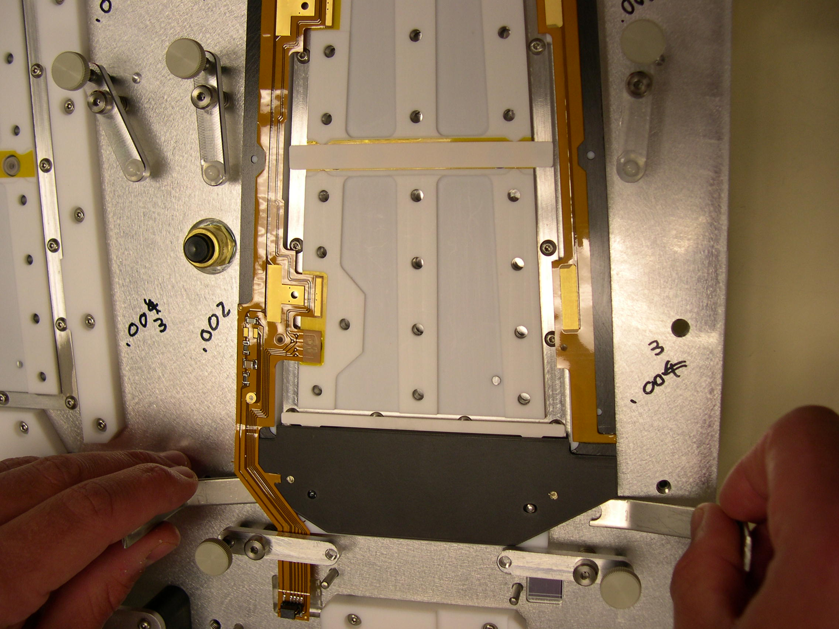
Using tools to safely remove TEC frame.
- Place module on carrier plate. For TOB modules affix the 1D barcode to the carrier plate.
- Carefully secure the module with the clamps.
- Place in a black esd box and put in cabinet on the “to be bonded” shelf.
- Remove tape with test lines of glue and add replace with a clean strip.

Section 5: Module reinforcement
After the modules have been bonded they need to be reinforced for shipping to prevent the wire bonds from breaking due to vibrations encountered during shipping. To reinforce the modules we use a bead of Sylgard 186 on the backside, in between the sensors and between the near sensor and the PA. This is only done with TOB modules because TEC modules have ceramic stiffeners. TOB modules should be glued on the same day that they are bonded so they can cure overnight and be ready for testing the next morning. The best time to glue modules is at the end of the day after building.
The glue is prepared in much the same way as the RTV 12 is for module production, only for the Sylgard there is a 10:1 ratio by weight of base to hardener ( is that what its actually called?). A good rough estimate for how much glue you need is to use about 1 gram of the base for every module plus and additional 1 gram, so if there are 15 modules to be reinforced then you should use about 16 grams of the silicon base. Mix the glue well; this will introduce a lot of air bubbles that need to be evacuated which will take some time, so it is recommended that you start mixing the glue 15-20 minutes before you plan to start working with it. The working time of the Sylgard is about an hour so there should be plenty of working time left after the bubbles are evacuated. When first putting the mixed glue into the vacuum chamber you should be sure and watch that it does not bubble over, this is very common when making amounts in excess of about 10 grams. If the glue looks like it might bubble, over open the purge valve a small amount and/or close the vacuum valve a small amount. This will probably have to be done several times before you can walk away from the vacuum chamber. When you are confident that the glue will not bubble over you can leave it to sit, it will take about 10-15 more minutes to get most of the remaining bubbles out. You do not need to get all the bubble out this first time around because there will be more bubbles introduced when putting the glue into the syringe. While you are waiting for the glue to evacuate you can use that time to remove the hybrid barcodes from the modules, this should be done very carefully so you don’t touch anything on the hybrid or modules, being especially careful of the wire bonds. Once the barcode is removed be sure to clean off any remaining adhesive with some alcohol and a foam swab.
Fit a 30 cc syringe barrel with an orange cap and fill it with the newly evacuated sylgard. Take care to add as few new air bubbles as possible, but it is basically impossible not to put at least a few in. Once all the sylgard is in the syringe place it in a small plastic bucket and return it to the vacuum chamber to get the rest of the air bubbles out. Once all the air bubbles are out, place the black plunger into the barrel and fit it with a pink tip, now you are ready to start gluing modules.
The glue gantry is located in the clean area in the anteroom. You should bring all the modules that are to be reinforced into the gluing area before you get started. To glue the modules connect the syringe to the EFD pneumatic glue dispenser. The air pressure should be set around 30 psi, make any adjustments needed, place the syringe in the holder on the mini gantry and push it all the way down. If it is not pushed all the way down it will not be at the correct height to dispense a nice bead of glue. Make sure the gantry and the EFD are connected, the cable should be connected from the gantry’s remote port to the EFD’s dispense port (verify names). Without this connection the two machines will not talk to each other and there will be no glue dispensed when the gantry program is run. Load the correct program on the gantry, for two modules it is program 13 (we need another program for just one module). Load up the modules and press start on the mini gantry. Be sure to watch the alignment of the syringe tip when the program is running, it is very easy for the tip to be slightly bend and not dispense the glue where it should on the module, this is easily fixed by gently guiding the tip to the correct location and holding it there while the program is running. Be careful when you are doing this not to touch the module, just the syringe tip. The program takes about a minute to run, after it is finished place the glued module in the module storage cabinet upside down to prevent the glue from dripping. The glue needs to cure over night. In the morning move cured modules back into the main clean room to be tested.
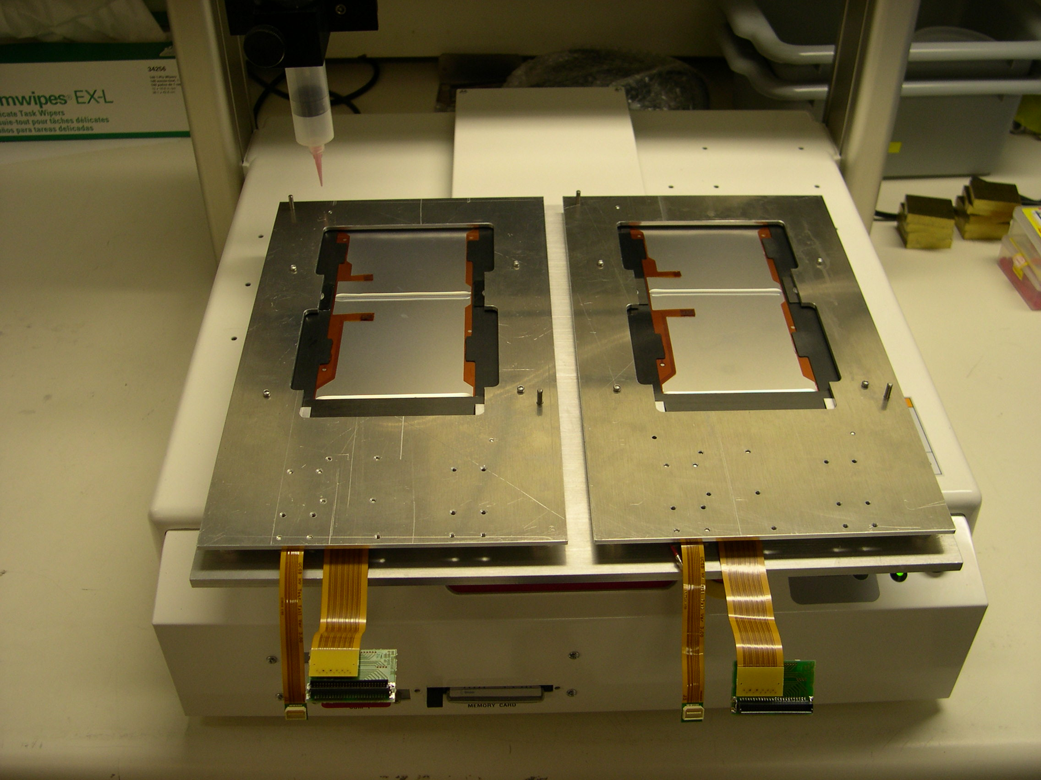

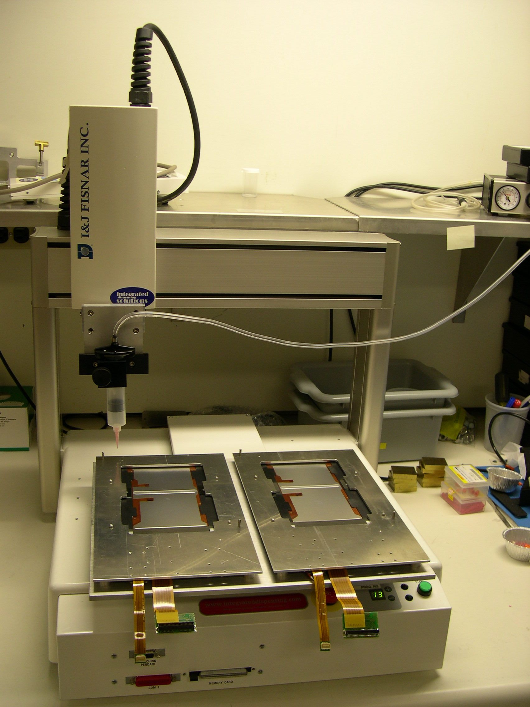

Appendix A: Troubleshooting Common Problems
- Sometimes when virtually assembling the modules in BigBrowser, a hybrid or a sensor is found that is marked faulty in the database.
The frequency that this problem crops up varies from one batch of components to the next. When this problem is encountered it is best to mark the component as faulty (on either the white sleeve if it is a sensor, or on the box if it is a hybrid) and get another hybrid or sensor pair. Note that if one sensor is faulty do not just grab another one, you must replace the whole pair. Let somebody in the testing room know of the situation; they will either reevaluate the component or find if it has just been a simple mistake.
- Occasionally you will have to re-place a component that has already been placed.
This comes up, for example, when a hybrid is placed but the vacuum is not good and pressure is lost. Leaving the hybrid assembled will endanger the proper curing of the other module components and even the other plates after this plate is attached to the curing pump. First thing first, pause the program. Pause it before the gantry has a chance to pick up another component, because that will just make things trickier. The main idea is to put all the pieces of the bad assembly (the poorly placed sensor or hybrid, the pick-up tool) back to their original positions and continue the assembly in Recovery Mode. Of course that is a bit trickier than it sounds.
To remove the pickup tool, abort the program and enter the gantry’s Manual mode of operation. From here you should home the gantry in the z direction to raise it up and away from all of the sensitive materials below. Home it by highlighting Z and pressing home. Now escape out of here and enter into the Virtual IO page, this is a menu item along the right hand side of the MMI. From here you can release the pickup tool by finding the correct IO output number on the chart in Appendix B (it should be valve 19 or IO output number 37). Make sure to have someone ready to catch the tool so that it doesn’t drop and hit something! From this IO page, you can additionally turn off the relevant component vacuum valve(s).
Now you can remove the component from its position on the frame. The component will resist being separated because there is glue residue between it and the frame, so take care. If you are moving a hybrid, it is ok to use your hands and pull on the tail. If you are, however, moving a sensor bring the manual vacuum pickup tool over and use it to pull up on the sensor face. After you have removed the component clean off all the areas with glue residue on them with alcohol and clean room Q-tips. Note that if you are building TEC modules you will more than likely also have to clean the TEC stiffener. Next, reposition all the components back to their original positions and reapply glue to areas that it is needed because you will not be able to apply glue in Recovery Mode (you can apply glue in Recovery Mode, but not just to one module position unless it is position 3). After this return to the IO page and reset any supply vacuums that need to be set. To finish just enter Recovery Mode and follow the steps outlined in Section 3.2.

Appendix B: Valve and digital I/O numbers

